DATE: 10.05.2019
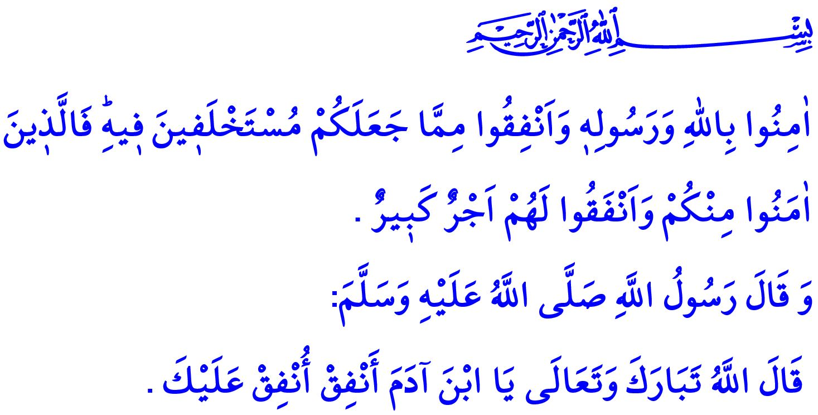
RAMADAN AND INFAQ
Honorable Believers!
The Almighty Allah (swt) states in the verse I have just recited: “Believe in Allah and His Messenger, and donate from what He has entrusted you with. So those of you who believe and donate will have a mighty reward.”
The Prophet Muhammad (saw) informs us in the hadith qudsi I have recited that the Almighty Allah (swt) states: “O, Children of Adam, Spend (on charity) and I shall spend on you.”
Dear Muslims!
Infaq means that believers spend out of their wealth to have the consent of Allah (swt). It is to help spouses, fellows, relatives and needy people. It is to let others benefit from the wealth bestowed to him by Allah (swt). It is to win the heart of his brother, to help the ones who are in need, and to offer the ones who are not in need. Prophet Muhammad (saw) points out in a hadith that infaq and sadaqah will not be unreciprocated and will be rewarded: “Without doubt sadaqah eases the wrath of Allah and saves you from dying in a bad way.”
Honorable Muslims!
Infaq enables humans to adopt a balanced attitude towards wealth. It prevents both being stingy due to ambition of owning property and squandering unwisely. It develops the feelings of brotherhood and sharing. The happiness and satisfaction of the needy people turn into peace and relief in the heart of the people who spend in charity. Therefore, believers reach to benevolence truly. In this regard, Allah the Exalted (swt) states in the Holy Qur’an: “You will never achieve righteousness until you donate some of what you cherish. And whatever you give is certainly well known to Allah.”
Dear Believers!
Islamic civilization that is built on iman, knowledge, wisdom and skill is also a civilization of infaq. Sharing, collaboration, solidarity and infaq are at the center of the lives of Muslims. Because our Beloved Prophet Muhammad (saw) advised this ummah to be like bricks of a building, organs of a body, and teeth of a comb. Muslims share their savings with their relatives, neighbors, close or distant coreligionists and the needy members of the family of humanity. They live by the principle in the verse of “Those who (in charity) spend of their goods by night and by day, in secret and in public, have their reward with their Lord: On them shall be no fear, nor shall they grieve.” They think of both their and the society’s goodness while working by day and night.
Honorable Muslims!
How sad it is that today we are combating with the disease of secularization which makes wealth the objective of life and fails to use it as a means. Selfishness, fondness for property, passion of power and interest, and lives based on show-off have been the disasters of this age. The virtues such as collaboration, solidarity and making sacrifice for others have been damaged. In such an age, the interminable desires and ambitions into which humanity is dragged can only be overcome by means of the awareness of infaq and collaboration. Those who are stingy and do not give the poor, needy, orphan, almsman, and people who are in financial difficulties and stranded their due will drag themselves and the humanity into calamity. Our Beloved Prophet (saw) warns us in his hadith: “Children of Adam say: ‘My wealth, my wealth.’ Do you own of your wealth other than what you eat and consume, and what you wear and wear out, or what you give in sadaqah (charity) (to those who deserve it), and that what you will have in stock for yourself?”
Dear Muslims!
The month of Ramadan is a unique opportunity for infaq, collaboration and sharing. In these days of Ramadan when we show our servitude to our Almighty Allah (swt) by means of various deeds, let us take needy people under our wings with our financial worships such as zakat and sadaqah al-fitr. Let us ease the pain of our brothers and sisters. Let us give our charity without show-off and only for having the consent of the Almighty Allah (swt). Let us avoid the attitudes that may hurt honor of our brothers and sisters while giving charity to them. Let us pay attention to the statement of Allah the Exalted (swt): “O believers! Donate from the best of what you have earned and of what We have produced for you from the earth. Do not pick out worthless things for donation, which you yourselves would only accept with closed eyes. And know that Allah is Self-Sufficient, Praiseworthy.”
Honorable Believers!
Our Presidency of Religious Affairs determined this year's theme of Ramadan as “Ramadan and Infaq”. With this occasion, the subject of infaq is going to be kept on the agenda in all aspects with the activities to be organized in homeland and abroad and it will be tried to create sensitivity about this subject. Thus, it will be tried to keep the awareness of collaboration and sharing alive and to expand the ethics of infaq further. Let us remember that the charities we give by observing the consent of our Almighty Allah (swt) are going to be our most beautiful food in the Hereafter.

Hadid, 57/7.
Muslim, Zakat, 36.
Tirmidhi, Zakat, 28.
Ali 'Imran, 3/92.
Baqarah, 2/274.
Muslim, Zuhd, 3.
Baqarah, 2/267. General Directorate of Religious Services

